How to use Excel to get the charts:

1. Type in a line with protocol type as well as trial number.
2. Type in a row with time intervals or output-number for each trial.
3. In the area between the line and row above in 1) & 2), type in the data gotten in the experiment accordingly.
4. Use the ‘Graph Tools’ in Excel to generate the graph needed. (Because each version of Excel has some differences in its graph tool, we don’t explain specifically how to use the tool. Tutorials can be found in the Internet.)
5. 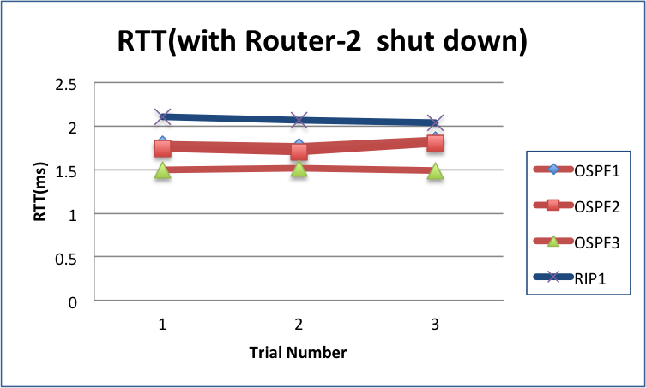Add graph title and other marks needed.

